Online Discussion Tool
Database Design

Functionalities
Common functionalities to all users:
- Login
- Logout
- Change Password

Functionalities performed by the instructor
- Retrieve a request to add a new student
- Add a new student to the course (same as “Enrolling a student”)
- Retrieve a request to remove a new student
- Remove a student from the course (same as “Dropping a student”)
- Create a new discussion
- Retrieve a request from a student to create a new discussion
- Browse all entries associated with a discussion
- Search for a discussion based on topic or date of creation
- Post an entry for a discussion (* requires selecting a discussion first *)
- Search for an entry in a discussion based on username or date of posting
- Remove an entry from a discussion (* requires selecting the entry first *)
- Browse all topics/discussions (same as “view all discussions”)
- Archive a discussion (* requires selecting the discussion first *)
- Browse all archived discussions (same as “view all archived discussions”)
- Retrieve a request from a student to retrieve an archived discussion
- Retrieve an archived discussion
- View all students in the course
Functionalities performed by a student
- Request to join the course (same as “enroll”)
- Request to leave the course (same as “drop the course”)
- Browse all topics/discussions
- Browse all entries in a discussion (* requires selecting a discussion first *)
- Post an entry (* requires selecting the discussion first *)
- Request to retrieve a discussion from the archive

Entities
These correspond to the tables of interest; the actual table structure may change.
Entity | Fields
LoginCredential | Username*  Password
StudentRecord | Firstname  Lastname  StudentID*  Email address
EnrollQueue | Sequence of StudentRecord
RemoveStudentQueue | Sequence of StudentID
Dicussion | DiscussionID*  CourseName  DateAndTimeOfCreation  Topic
ReuqestToCreateDiscussion | StudentID*  Topic*
Message | MessageID*  DateAndTime*  Username*  Contents
DiscussionToMessage | DicussionID*  MessageID*
ArchivedDicussions | Sequence of Discussion
RequestToRetrieveDiscussion | StudentID*  Topic*
‘*’ indicates primary key

E-R Diagram
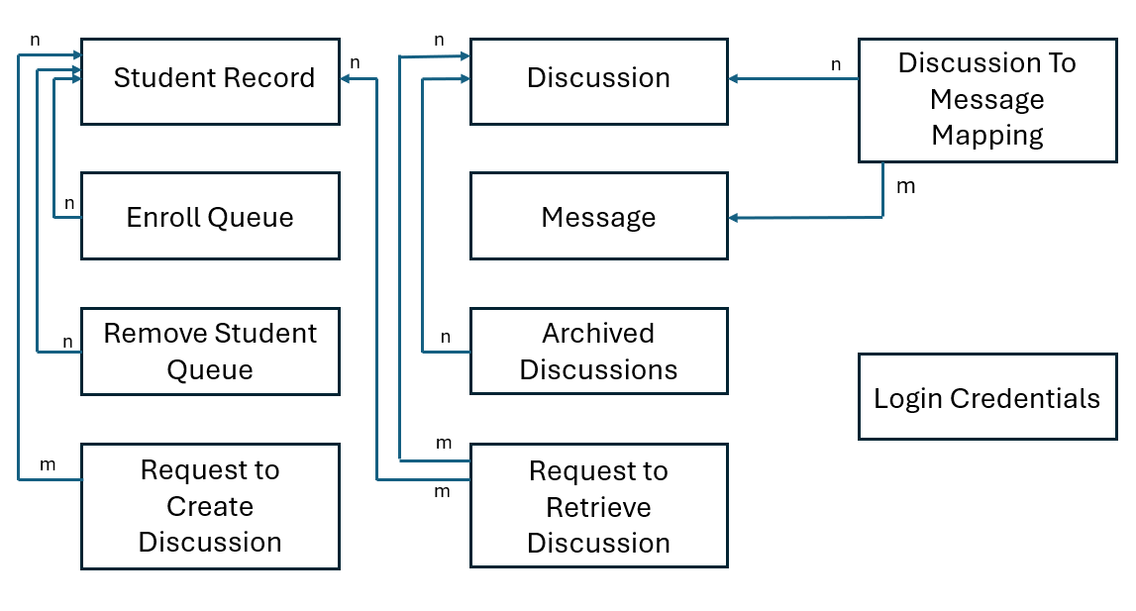
If there is no cardinality specified on any one end of a relation, it is assumed to be ‘1’.

Relationships in tabular format
From | To | Cardinality
Enroll Queue | Student Record | Many-to-one
Remove Student Queue | Student Record | Many-to-one
Request to Create Discussion | Student Record | Many-to-one
Discussion to Message Mapping | Discussion | Many-to-one
Discussion to Message Mapping | Message | Many-to-one
Archived Discussions | Discussion | Many-to-one
Request to Retrieve Discussion | Discussion | Many-to-many
Request to Retrieve Discussion | Student Record | Many-to-Many

